JAVA

Program1.

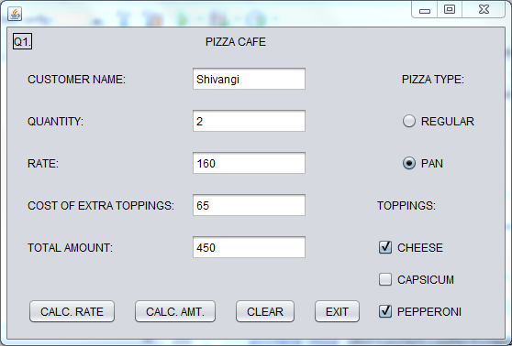

CODING:

private void jButton1ActionPerformed(java.awt.event.ActionEvent evt) {

int rate=0;

if (jRadioButton1.isSelected())

{

rate=rate+120;

jTextField3.setText(Integer.toString(rate));

}

else if(jRadioButton2.isSelected())

{

rate=rate+160;

jTextField3.setText(Integer.toString(rate));

}

private void jButton2ActionPerformed(java.awt.event.ActionEvent evt) {

int qty,rate,cot=0,amount=0;

qty=Integer.parseInt(jTextField2.getText());

rate=Integer.parseInt(jTextField3.getText());

if (jCheckBox1.isSelected())

{

cot=cot+40;

}

if (jCheckBox2.isSelected())

{

cot=cot+20;

}

if (jCheckBox3.isSelected())

{

cot=cot+25;

}

jTextField4.setText(Integer.toString(cot));

amount=amount+(cot+rate)*qty;

jTextField5.setText(Integer.toString(amount));

private void jButton3ActionPerformed(java.awt.event.ActionEvent evt) {

jTextField1.setText("");

jTextField2.setText("");

jTextField3.setText("");

jTextField4.setText("");

jTextField5.setText("");

jRadioButton1.setSelected(false);

jRadioButton2.setSelected(false);

jCheckBox1.setSelected(false);

jCheckBox2.setSelected(false);

jCheckBox3.setSelected(false);

private void jButton4ActionPerformed(java.awt.event.ActionEvent evt) {

System.exit(0);

Program2.

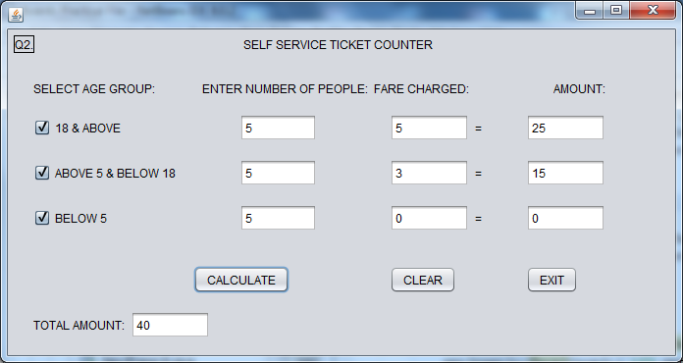

CODING:

private void jButton1ActionPerformed(java.awt.event.ActionEvent evt) {

int fare1=0,fare2=0,fare3=0,nop1,nop2,nop3,amt1=0,amt2=0,amt3=0,totalamount=0;

nop1=Integer.parseInt(tf1.getText());

nop2=Integer.parseInt(tf2.getText());

nop3=Integer.parseInt(tf3.getText());

if (jCheckBox1.isSelected())

{

fare1=fare1+5;

tf4.setText(Integer.toString(fare1));

amt1=amt1+(fare1*nop1); tf7.setText(Integer.toString(amt1));

}

if (jCheckBox2.isSelected())

{

fare2=fare2+3;

tf5.setText(Integer.toString(fare2));

amt2=amt2+(fare2*nop2); tf8.setText(Integer.toString(amt2));

}

if (jCheckBox3.isSelected())

{

fare3=fare3;

tf6.setText(Integer.toString(fare3));

amt3=amt3+(fare3*nop3); tf9.setText(Integer.toString(amt3));

}

totalamount=totalamount+amt1+amt2+amt3;

tf10.setText(Integer.toString(totalamount));

}

private void jButton2ActionPerformed(java.awt.event.ActionEvent evt) {

tf1.setText("");

tf2.setText("");

tf3.setText("");

tf4.setText("");

tf5.setText("");

tf6.setText("");

tf7.setText("");

tf8.setText("");

tf9.setText("");

tf10.setText("");

}

private void jButton3ActionPerformed(java.awt.event.ActionEvent evt) { System.exit(0); }

Program3.

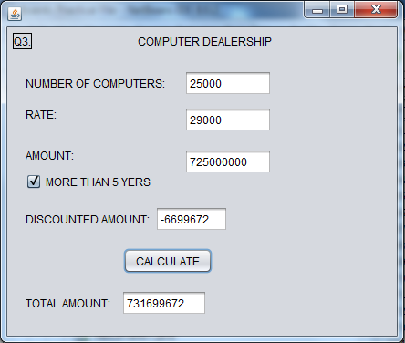

CODING:

private void jButton1ActionPerformed(java.awt.event.ActionEvent evt) {

int number,rate=0,amount,totalamt,discount,discamt=0;

number=Integer.parseInt(jTextField1.getText());

if (number<20)

{

rate=rate+35000;

jTextField2.setText(Integer.toString(rate));

}

else if ((number >20)&&(number<40))

{

rate=rate+31000;

jTextField2.setText(Integer.toString(rate));

}

else if (number>40)

{

rate=rate+29000;

jTextField2.setText(Integer.toString(rate));

}

amount=rate*number;

jTextField3.setText(Integer.toString(amount));

if (jCheckBox1.isSelected())

{

discount=5;

discamt=discamt+(number*rate)*5/100;

}

jTextField4.setText(Integer.toString(discamt));

totalamt=(number*rate)-discamt;

jTextField5.setText(Integer.toString(totalamt));

Program4.

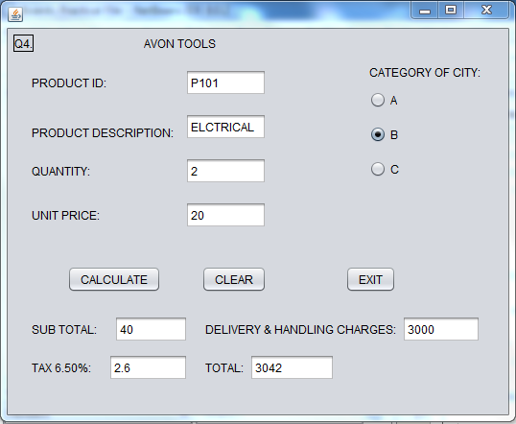

CODING:

private void jButton1ActionPerformed(java.awt.event.ActionEvent evt) {

int qty,price,subtotal,delivery=0,total;

double tax;

qty=Integer.parseInt(jTextField3.getText());

price=Integer.parseInt(jTextField4.getText());

subtotal=qty*price;

jTextField5.setText(Integer.toString(subtotal));

tax=subtotal*6.5/100;

jTextField6.setText(Double.toString(tax));

if (jRadioButton1.isSelected())

{

delivery=delivery+2000;

jTextField7.setText(Integer.toString(delivery));

}

else if(jRadioButton2.isSelected())

{

delivery=delivery+3000;

jTextField7.setText(Integer.toString(delivery));

}

else if(jRadioButton3.isSelected())

{

delivery=delivery+3500;

jTextField7.setText(Integer.toString(delivery));

}

jTextField7.setText(Integer.toString(delivery));

total=(int) (delivery+subtotal+tax);

jTextField8.setText(Integer.toString(total));

private void jButton2ActionPerformed(java.awt.event.ActionEvent evt) {

jTextField1.setText("");

jTextField2.setText("");

jTextField3.setText("");

jTextField4.setText("");

jTextField5.setText("");

jTextField6.setText("");

jTextField7.setText("");

jTextField8.setText("");

jRadioButton1.setSelected(false);

jRadioButton2.setSelected(false);

jRadioButton3.setSelected(false);

private void jButton3ActionPerformed(java.awt.event.ActionEvent evt) {

System.exit(0);

Program5.

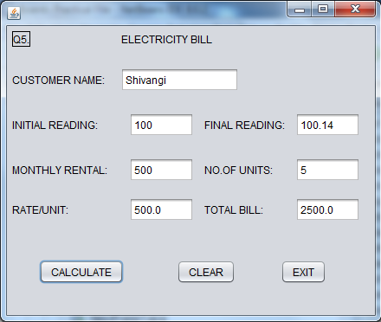

CODING:

private void jButton2ActionPerformed(java.awt.event.ActionEvent evt) {

jTextField1.setText("");

jTextField2.setText("");

jTextField3.setText("");

jTextField4.setText("");

jTextField5.setText("");

jTextField6.setText("");

jTextField7.setText("");

}

private void jButton1ActionPerformed(java.awt.event.ActionEvent evt) {

int a,b,c;

double f = 0,g = 0,h=0,d = 0,e = 0;

a=Integer.parseInt(jTextField2.getText());

b=Integer.parseInt(jTextField5.getText());

jTextField3.setText("500");

c=b-a;

jTextField6.setText(Integer.toString(c));

if(c<100)

{

d=500;

h=h+d;

}

else if(c>100 || c<200)

{

d=500;

c=c-100;

e=c*1;

h=h+d+e;

}

else if(c>200 || c<300)

{

d=500;

c=c-100;

e=100*1;

c=c-100;

f=c*1.2;

h=h+d+e+f;

}

else if(c>300)

{

d=500;

c=c-100;

e=100*1;

f=100*(1.2);

c=c-200;

g=c*1.5;

h=h+d+e+f+g;

}

jTextField7.setText(Double.toString(h));

}

private void jButton3ActionPerformed(java.awt.event.ActionEvent evt) {

System.exit(0);

Program6.

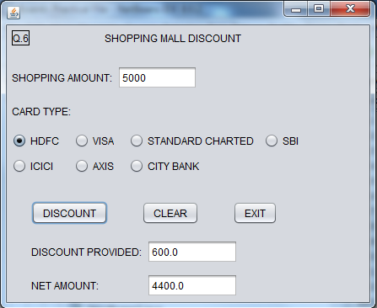

CODING:

private void jButton1ActionPerformed(java.awt.event.ActionEvent evt) {

double amt,discount=0,discamt=0,netamt;

amt=Double.parseDouble(jTextField1.getText());

if (jRadioButton1.isSelected())

{

discount=discount+12;

discamt=discamt+(amt*discount)/100;

}

else if (jRadioButton2.isSelected())

{

discount=discount+10;

discamt=discamt+(amt*discount)/100;

}

else if (jRadioButton3.isSelected())

{

discount=discount+9.5;

discamt=discamt+(amt*discount)/100;

}

else if (jRadioButton4.isSelected())

{

discount=discount+10.5;

discamt=discamt+(amt*discount)/100;

}

else if (jRadioButton5.isSelected())

{

discount=discount+8.5;

discamt=discamt+(amt*discount)/100;

}

else if (jRadioButton6.isSelected())

{

discount=discount+11.5;

discamt=discamt+(amt*discount)/100;

}

else if (jRadioButton7.isSelected())

{

discount=discount+8;

discamt=discamt+(amt*discount)/100;

}

jTextField2.setText(Double.toString(discamt));

netamt=amt-discamt;

jTextField3.setText(Double.toString(netamt));

private void jButton2ActionPerformed(java.awt.event.ActionEvent evt) {

jTextField1.setText("");

jTextField2.setText("");

jTextField3.setText("");

private void jButton3ActionPerformed(java.awt.event.ActionEvent evt) {

System.exit(0);

Program7.A).

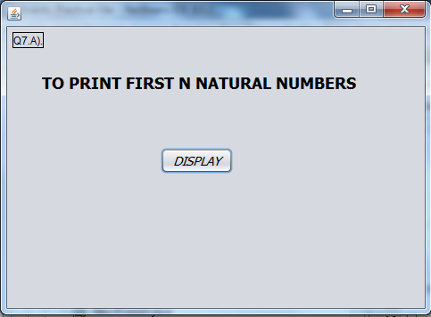

CODING:

private void jButton1ActionPerformed(java.awt.event.ActionEvent evt) {

int i,n=7;

for(i=1;i<=n;++i)

{

System.out.println(i);

}

Program7.B).

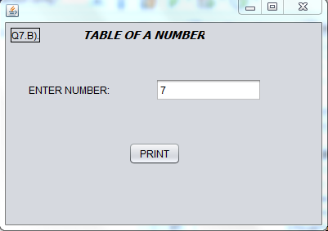

CODING:

private void jButton1ActionPerformed(java.awt.event.ActionEvent evt) {

int num,t;

num=Integer.parseInt(jTextField1.getText());

for(int i=1;i<=10;i++){

t=num*i;

System.out.println(""+num+"*"+""+i+"="+""+t);

}

Program8.A).

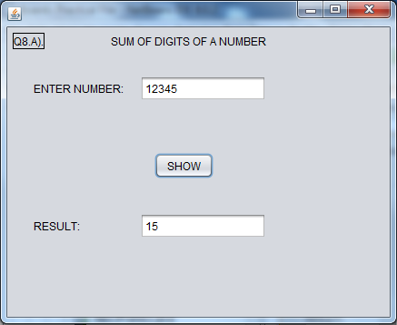

CODING:

private void jButton1ActionPerformed(java.awt.event.ActionEvent evt) {

int n,dig,s=0;

n=Integer.parseInt(jTextField1.getText());

while (n>0)

{

dig=n%10;

s=s+dig;

n=n/10;

}

jTextField2.setText(Integer.toString(s));

Program8.B).

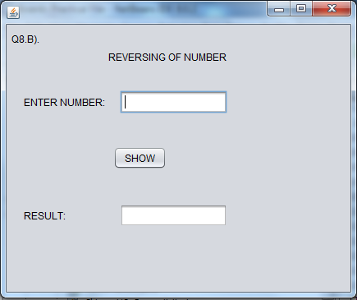

CODING:

private void jButton1ActionPerformed(java.awt.event.ActionEvent evt) {

int num,n,digit,rev=0;

num=Integer.parseInt(jTextField1.getText());

n=num; do {

digit=num%10;

rev=(rev*10)+digit;

num=num/10; }

while (num!=10);

jTextField2.setText(Integer.toString(rev));

if (num==rev)

JOptionPane.showMessageDialog(this,"THIS NUMBER IS A PALINDROME");

else

JOptionPane.showMessageDialog(this,"THIS NUMBER IS NOT A PALINDROME");

Program8.C).

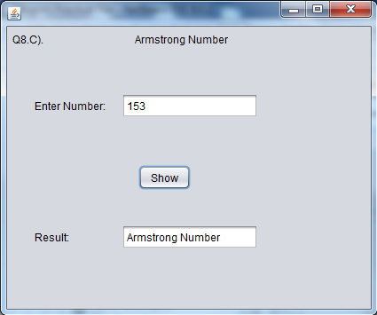

CODING:

private void jButton1ActionPerformed(java.awt.event.ActionEvent evt) {

int c=0,n,a,temp;

n=Integer.parseInt(jTextField1.getText());

temp=n;

while (n>0) {

a=n%10;

n=n/10;

c=c+(a*a*a) }

{

if(temp==c)

jTextField2.setText("Armstrong Number");

else

jTextField2.setText("Not an Armstrong Number"); }

Program9.

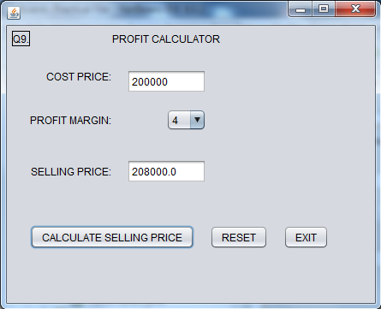

CODING:

private void jButton1ActionPerformed(java.awt.event.ActionEvent evt) {

double cp,pm=0,sp;

cp=Double.parseDouble(jTextField1.getText());

pm=jComboBox1.getSelectedIndex();

sp=cp+cp*(pm/100);

jTextField2.setText(Double.toString(sp));

private void jButton2ActionPerformed(java.awt.event.ActionEvent evt) {

jTextField1.setText("");

jTextField2.setText("");

jComboBox1.setSelectedIndex(0);

private void jButton3ActionPerformed(java.awt.event.ActionEvent evt) {

System.exit(0);

Program10.

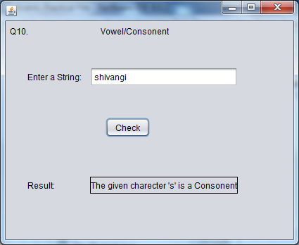

CODING:

private void jButton1ActionPerformed(java.awt.event.ActionEvent evt) {

char n=jTextField1.getText().charAt(0);

switch(n) {

case'a': jLabel5.setText("The given charecter '"+n+"' is a Vowel");

break;

case'e':jLabel5.setText("The given charecter '"+n+"' is a Vowel");

break;

case'i':jLabel5.setText("The given charecter '"+n+"' is a Vowel");

break;

case'o':jLabel5.setText("The given charecter '"+n+"' is a Vowel");

break;

case'u':jLabel5.setText("The given charecter '"+n+"' is a Vowel");

break;

default:jLabel5.setText("The given charecter '"+n+"' is a Consonent"); }

Program11.

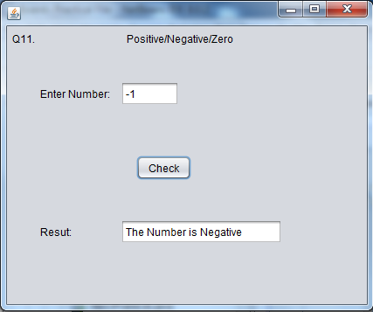

CODING:

private void jButton1ActionPerformed(java.awt.event.ActionEvent evt) {

int n;

n=Integer.parseInt(jTextField1.getText());

if (n>0)

jTextField2.setText("The Number is Positive");

else if (n<0)

jTextField2.setText("The Number is Negative");

else if (n==0)

jTextField2.setText("The Number is Zero");

}

Program12.

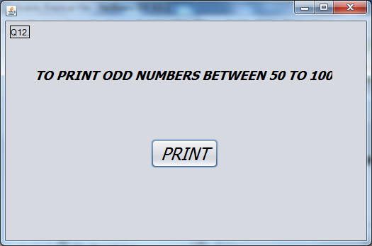

CODING:

private void jButton1ActionPerformed(java.awt.event.ActionEvent evt) {

int sum=0,x;

for (x=51;x<=100;x+=2){

System.out.println(x);

sum=sum+x;

}

System.out.println("sum="+sum);

Program13.

mysql> create table student

-> (

-> rollno int primary key,

-> name varchar(20) ,

-> class varchar(10),

-> dob date not null,

-> gender char,

-> percent int

-> );

Query OK, 0 rows affected (0.26 sec)

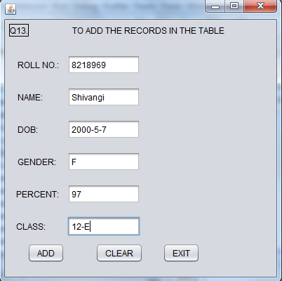

Coding:

import com.mysql.jdbc.Connection;

import com.mysql.jdbc.Statement;

import java.sql.DriverManager;

import javax.swing.JOptionPane;

private void jButton1ActionPerformed(java.awt.event.ActionEvent evt) {

String rollno=jTextField1.getText();

String name=jTextField2.getText();

String dob=jTextField3.getText();

String gender=jTextField4.getText();

String percent=jTextField5.getText();

String clas=jTextField6.getText();

try

{

Class.forName("java.sql.DriverManager");

Connection con=(Connection)

DriverManager.getConnection

("jdbc:mysql://localhost:3306/boardspracfile","root","7578");

Statement stmt=(Statement) con.createStatement();

String query="insert into student values('"+rollno+"','"+name+"','"+dob+"','"+gender+"','"+percent+"','"+clas+"');";

stmt.executeUpdate(query);

JOptionPane.showMessageDialog(this,"ADDED");

}

catch (Exception e)

{

JOptionPane.showMessageDialog(this,e.getMessage());

}

private void jButton2ActionPerformed(java.awt.event.ActionEvent evt) {

jTextField1.setText("");

jTextField2.setText("");

jTextField3.setText("");

jTextField4.setText("");

jTextField5.setText("");

jTextField6.setText("");

private void jButton3ActionPerformed(java.awt.event.ActionEvent evt) {

System.exit(0);

Program14.

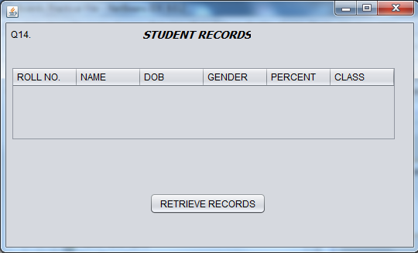

CODING:

import javax.swing.table.DefaultTableModel;

import java.sql.DriverManager;

import com.mysql.jdbc.Connection;

import com.mysql.jdbc.Statement;

import java.sql.ResultSet;

import javax.swing.JOptionPane;

private void jButton1ActionPerformed(java.awt.event.ActionEvent evt) {

DefaultTableModel model=(DefaultTableModel)jTable1.getModel();

try

{

Class.forName("java.sql.DriverManager");

Connection con=(Connection)

DriverManager.getConnection

("jdbc:mysql://localhost:3306/boardspracfile","root","7578");

Statement stmt=(Statement) con.createStatement();

String query="select * from student;";

ResultSet rs=stmt.executeQuery(query);

while (rs.next())

{

String rollno=rs.getString("rollno");

String name=rs.getString("name");

String dob=rs.getString("dob");

String gender=rs.getString("gender");

String percent=rs.getString("percent");

String clas=rs.getString("clas");

model.addRow(new Object[]{rollno,name,dob,gender,percent,clas});

}

rs.close();

stmt.close();

con.close();

}

catch(Exception e)

{

JOptionPane.showMessageDialog(this,"error in connectivity"+e);

}

Program15.

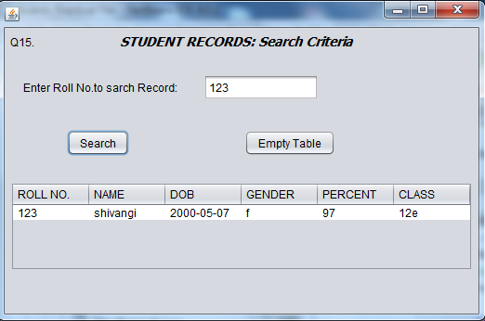

CODING:

private void jButton1ActionPerformed(java.awt.event.ActionEvent evt) {

String rollno=jTextField1.getText();

DefaultTableModel model=(DefaultTableModel)jTable1.getModel();

try

{

Class.forName("java.sql.DriverManager");

Connection con=(Connection)

DriverManager.getConnection

("jdbc:mysql://localhost:3306/boardspracfile","root","7578");

Statement stmt=(Statement) con.createStatement();

String query="select * from student where rollno='"+rollno+"';";

ResultSet rs=stmt.executeQuery(query);

while (rs.next())

{

String name=rs.getString("name");

String dob=rs.getString("dob");

String gender=rs.getString("gender");

String percent=rs.getString("percent");

String clas=rs.getString("clas");

model.addRow(new Object[]{rollno,name,dob,gender,percent,clas});

}

}

catch(Exception e)

{

JOptionPane.showMessageDialog(this,e.getMessage());

}

}

private void jButton2ActionPerformed(java.awt.event.ActionEvent evt) {

DefaultTableModel model=(DefaultTableModel)

jTable1.getModel(); int rows=model.getRowCount();

if (rows>0)

{

for(int i=0;i<rows;i++)

model.removeRow(0);

}

}

Program16.

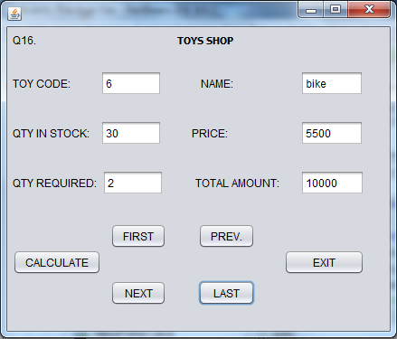

CODING:

private void jButton1ActionPerformed(java.awt.event.ActionEvent evt) {

int price,qty,amt;

price=Integer.parseInt(jTextField4.getText());

qty=Integer.parseInt(jTextField5.getText());

amt=price*qty;

jTextField6.setText(Integer.toString(amt));

}

private void jButton2ActionPerformed(java.awt.event.ActionEvent evt) {

try

{

Class.forName("java.sql.DriverManager");

Connection con=(Connection)

DriverManager.getConnection("jdbc:mysql://localhost:3306/boardspracfile","root","7578");

Statement stmt=(Statement) con.createStatement();

String query="select* from toys;";

ResultSet rs=stmt.executeQuery(query);

rs.last();

while (rs.next())

{

String toycode=rs.getString("toycode");

String name=rs.getString("name");

String qtyinstock=rs.getString("qtyinstock");

String price=rs.getString("price");

jTextField1.setText(toycode);

jTextField2.setText(name);

jTextField3.setText(qtyinstock);

jTextField4.setText(price);

}

rs.close();

stmt.close();

con.close();

}

catch (Exception e)

{

JOptionPane.showMessageDialog(this,""+e.getMessage());

}

}

private void jButton3ActionPerformed(java.awt.event.ActionEvent evt) {

ResultSet rs=new Q15().sql("select * from toys");

int y=0;

try

{

while (rs.next())

{

String toycode=rs.getString("toycode");

String name=rs.getString("name");

String qtyinstock=rs.getString("qtyinstock");

String price=rs.getString("price");

jTextField1.setText(toycode);

jTextField2.setText(name);

jTextField3.setText(qtyinstock);

jTextField4.setText(price);

if(y==x+1)

{

x=y;

break;

}

y++;

}

}

catch (Exception e)

{

JOptionPane.showMessageDialog(this,e);

}

}

private void jButton5ActionPerformed(java.awt.event.ActionEvent evt) {

try

{

Class.forName("java.sql.DriverManager");

Connection con=(Connection)

DriverManager.getConnection("jdbc:mysql://localhost:3306/boardspracfile","root","7578");

Statement stmt=(Statement) con.createStatement();

String query="select* from toys;";

ResultSet rs=stmt.executeQuery(query);

rs.first();

while (rs.next())

{

String toycode=rs.getString("toycode");

String name=rs.getString("name");

String qtyinstock=rs.getString("qtyinstock");

String price=rs.getString("price");

jTextField1.setText(toycode);

jTextField2.setText(name);

jTextField3.setText(qtyinstock);

jTextField4.setText(price);

}

rs.close();

stmt.close();

con.close();

}

catch (Exception e)

{

JOptionPane.showMessageDialog(this,""+e.getMessage());

}

}

private void jButton6ActionPerformed(java.awt.event.ActionEvent evt) {

System.exit(0);

}

Program17.

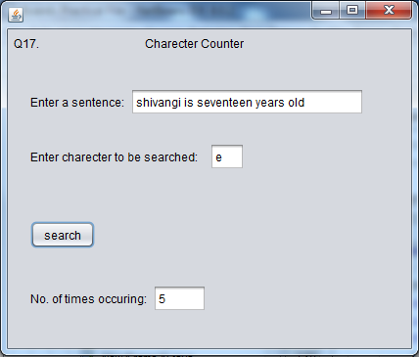

CODING:

private void jButton1ActionPerformed(java.awt.event.ActionEvent evt) {

String str=jTextField1.getText();

char ch=jTextField2.getText().charAt(0);

int count=0;

for(int i=0;i<str.length();i++)

{

if(str.charAt(i)==ch)

count++;

}

jTextField3.setText(""+count);

}

Program18.

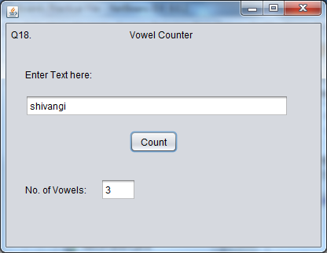

CODING:

private void jButton1ActionPerformed(java.awt.event.ActionEvent evt) {

String str=jTextField1.getText();

int vowel=0;

for(int i=0;i<str.length();++i)

{

char ch=str.charAt(i);

if(ch=='a'||ch=='e'||ch=='i'||ch=='o'||ch=='u'){

vowel++;

}

}

jTextField2.setText(Integer.toString(vowel));

}

Program19.

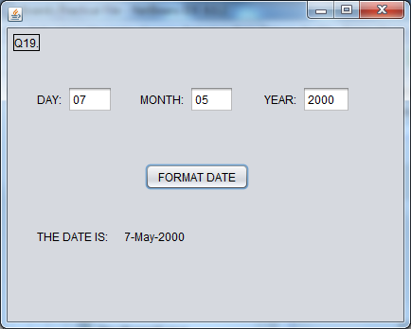

CODING:

private void formatButtonActionPerformed(java.awt.event.ActionEvent evt) {

String txt=dayTF.getText();

int day=Integer.parseInt(txt);

String txt1=monthTF.getText();

int mon=Integer.parseInt(txt1);

String txt2=yearTF.getText();

int yr=Integer.parseInt(txt2);

switch (mon){

case 1:dateLabel.setText(""+day+"-"+"Jan"+"-"+yr);

break;

case 2:dateLabel.setText(""+day+"-"+"Feb"+"-"+yr);

break;

case 3:dateLabel.setText(""+day+"-"+"Mar"+"-"+yr);

break;

case 4:dateLabel.setText(""+day+"-"+"Apr"+"-"+yr);

break;

case 5:dateLabel.setText(""+day+"-"+"May"+"-"+yr);

break;

case 6:dateLabel.setText(""+day+"-"+"Jun"+"-"+yr);

break;

case 7:dateLabel.setText(""+day+"-"+"Jul"+"-"+yr);

break;

case 8:dateLabel.setText(""+day+"-"+"Aug"+"-"+yr);

break;

case 9:dateLabel.setText(""+day+"-"+"Sep"+"-"+yr);

break;

case 10:dateLabel.setText(""+day+"-"+"Oct"+"-"+yr);

break;

case 11:dateLabel.setText(""+day+"-"+"Nov"+"-"+yr);

break;

case 12:dateLabel.setText(""+day+"-"+"Dec"+"-"+yr);

break;

}

Program20.

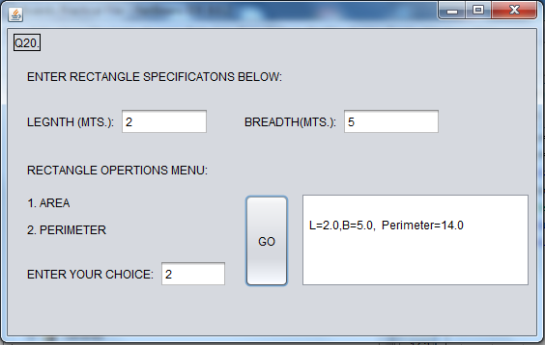

CODING:

private void jButton1ActionPerformed(java.awt.event.ActionEvent evt) {

double ln,br;

ln=Double.parseDouble(jTextField1.getText());

br=Double.parseDouble(jTextField2.getText());

int choice;

choice=Integer.parseInt(jTextField3.getText());

jTextArea1.setText("");

double l=ln;

switch (choice)

{

case 1:do

{

double ar=l*br;

jTextArea1.append("\n" +"L=" +l +",B=" + br+", Area="+ ar);

l=(l-2.0);

}

while (l>0.0);

break;

case 2:do

{

double pm=2*(l+br);

jTextArea1.append("\n" +"L=" +l +",B=" + br+", Perimeter="+ pm);

l=(l-2.0);

} while (l>0.0);

break;

}

Program21.

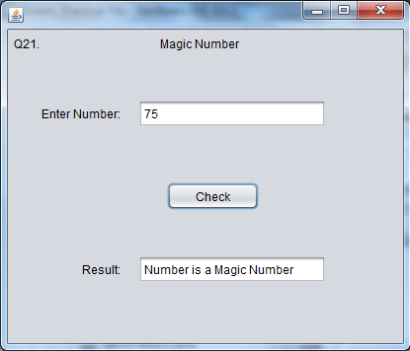

CODING:

private void jButton1ActionPerformed(java.awt.event.ActionEvent evt) {

double a=Integer.parseInt(jTextField1.getText());

String str=jTextField1.getText();

int total;

total=str.length();

double b,c;

b=a*a*a;

c=b%(Math.pow(10,total));

if(c==a)

{

jTextField2.setText("Number is a Magic Number");

}

else{

jTextField2.setText("Number is not a Magic Number"); }

MySQL QUESTIONS

Q1. mysql> create table teacher

-> (

-> no int,

-> name varchar(20),

-> age int,

-> dept varchar(20),

-> doj date,

-> salary int,

-> sex char

-> );

Query OK, 0 rows affected (0.12 sec)

mysql> insert into teacher values(1,'jugal',34,'computer','20011230',12000,'m');

Query OK, 1 row affected (0.38 sec)

mysql> insert into teacher values(2,'sharmila',31,'history','20040518',20000,'f');

Query OK, 1 row affected (1.13 sec)

mysql> insert into teacher values(3,'sandeep',32,'maths',19980706,30000,'m');

Query OK, 1 row affected (0.04 sec)

mysql> insert into teacher values(4,'sangeeta',25,'history',20010829,40000,'f');

Query OK, 1 row affected (0.04 sec)

mysql> insert into teacher values(5,'rakesh',42,'maths',20050917,25000,'m');

Query OK, 1 row affected (0.04 sec)

mysql> insert into teacher values(6,'shyam',50,'history',20070609,30000,'m');

Query OK, 1 row affected (0.03 sec)

mysql> insert into teacher values(7,'shiv om',44,'computer',20050219,21000,'m');

Query OK, 1 row affected (0.03 sec)

mysql> insert into teacher values(8,'shalakha',33,'maths',19991112,20000,'f');

Query OK, 1 row affected (0.03 sec)

mysql> select * from teacher;

+------+----------+------+----------+------------+--------+------+

| no | name | age | dept | doj | salary | sex |

+------+----------+------+----------+------------+--------+------+

| 1 | jugal | 34 | computer | 2001-12-30 | 12000 | m |

| 2 | sharmila | 31 | history | 2004-05-18 | 20000 | f |

| 3 | sandeep | 32 | maths | 1998-07-06 | 30000 | m |

| 4 | sangeeta | 25 | history | 2001-08-29 | 40000 | f |

| 5 | rakesh | 42 | maths | 2005-09-17 | 25000 | m |

| 6 | shyam | 50 | history | 2007-06-09 | 30000 | m |

| 7 | shiv om | 44 | computer | 2005-02-19 | 21000 | m |

| 8 | shalakha | 33 | maths | 1999-11-12 | 20000 | f |

+------+----------+------+----------+------------+--------+------+

8 rows in set (0.00 sec)

QUERIES:

mysql> select * from teacher where dept='history';

+------+----------+------+---------+------------+--------+------+

| no | name | age | dept | doj | salary | sex |

+------+----------+------+---------+------------+--------+------+

| 2 | sharmila | 31 | history | 2004-05-18 | 20000 | f |

| 4 | sangeeta | 25 | history | 2001-08-29 | 40000 | f |

| 6 | shyam | 50 | history | 2007-06-09 | 30000 | m |

+------+----------+------+---------+------------+--------+------+

3 rows in set (0.04 sec)

mysql> select name from teacher where sex='f' and dept='maths';

+----------+

| name |

+----------+

| shalakha |

+----------+

1 row in set (0.00 sec)

mysql> select name from teacher order by doj;

+----------+

| name |

+----------+

| sandeep |

| shalakha |

| sangeeta |

| jugal |

| sharmila |

| shiv om |

| rakesh |

| shyam |

+----------+

8 rows in set (0.20 sec)

mysql> select name, salary,age from teacher where sex='m';

+---------+--------+------+

| name | salary | age |

+---------+--------+------+

| jugal | 12000 | 34 |

| sandeep | 30000 | 32 |

| rakesh | 25000 | 42 |

| shyam | 30000 | 50 |

| shiv om | 21000 | 44 |

+---------+--------+------+

5 rows in set (0.01 sec)

mysql> select count(*) from teacher where age>23;

+----------+

| count(*) |

+----------+

| 8 |

+----------+

1 row in set (0.01 sec)

mysql> select name,salary,age from teacher where year(doj)>1997;

+----------+--------+------+

| name | salary | age |

+----------+--------+------+

| jugal | 12000 | 34 |

| sharmila | 20000 | 31 |

| sandeep | 30000 | 32 |

| sangeeta | 40000 | 25 |

| rakesh | 25000 | 42 |

| shyam | 30000 | 50 |

| shiv om | 21000 | 44 |

| shalakha | 20000 | 33 |

+----------+--------+------+

8 rows in set (0.00 sec)

mysql> select count(*) from teacher where salary between 20000 and 30000;

+----------+

| count(*) |

+----------+

| 6 |

+----------+

1 row in set (0.01 sec)

mysql> select name,salary*10/100+salary as 'new sal' from teacher;

+----------+------------+

| name | new sal |

+----------+------------+

| jugal | 13200.0000 |

| sharmila | 22000.0000 |

| sandeep | 33000.0000 |

| sangeeta | 44000.0000 |

| rakesh | 27500.0000 |

| shyam | 33000.0000 |

| shiv om | 23100.0000 |

| shalakha | 22000.0000 |

+----------+------------+

8 rows in set (0.01 sec)

mysql> select name,dept from teacher where name like's%';

+----------+----------+

| name | dept |

+----------+----------+

| sharmila | history |

| sandeep | maths |

| sangeeta | history |

| shyam | history |

| shiv om | computer |

| shalakha | maths |

+----------+----------+

6 rows in set (0.00 sec)

mysql> select upper (name) from teacher;

+--------------+

| upper (name) |

+--------------+

| JUGAL |

| SHARMILA |

| SANDEEP |

| SANGEETA |

| RAKESH |

| SHYAM |

| SHIV OM |

| SHALAKHA |

+--------------+

8 rows in set (0.01 sec)

mysql> select max(salary) from teacher;

+-------------+

| max(salary) |

+-------------+

| 40000 |

+-------------+

1 row in set (0.00 sec)

mysql> select avg(salary) from teacher where dept='maths';

+-------------+

| avg(salary) |

+-------------+

| 25000.0000 |

+-------------+

1 row in set (0.00 sec)

mysql> select substr(dept,1,3) from teacher;

+------------------+

| substr(dept,1,3) |

+------------------+

| com |

| his |

| mat |

| his |

| mat |

| his |

| com |

| mat |

+------------------+

8 rows in set (0.00 sec)

Q2. mysql> create table bus

-> (

-> busno int,

-> origin varchar(20),

-> dest varchar(20),

-> rate decimal(6,3),

-> km int,

-> time decimal(6,3),

-> type varchar(20)

-> );

Query OK, 0 rows affected (0.08 sec)

mysql> insert into bus values(21,'del','jul',45.5,210,9.50,'ac');

Query OK, 1 row affected (0.02 sec)

mysql> insert into bus values(198,'del','amrit',NULL,250,10.00,NULL);

Query OK, 1 row affected (0.03 sec)

mysql> insert into bus values(101,'chandi','del',12.5,250,22.00,'NON');

Query OK, 1 row affected (0.03 sec)

mysql> insert into bus values(49,'mum','pune',35.0,205,11.00,'NON');

Query OK, 1 row affected (0.03 sec)

mysql> insert into bus values(12,'del','agra',50.0,330,6.00,'ac');

Query OK, 1 row affected (0.02 sec)

mysql> insert into bus values(25,'del','hrdw',20.5,250,5.00,'NON');

Query OK, 1 row affected (0.02 sec)

mysql> insert into bus values(24,'del','agra',25.0,330,8.30,'NON');

Query OK, 1 row affected (0.02 sec)

mysql> select * from bus;

+-------+--------+-------+--------+------+--------+------+

| busno | origin | dest | rate | km | time | type |

+-------+--------+-------+--------+------+--------+------+

| 21 | del | jul | 45.500 | 210 | 9.500 | ac |

| 198 | del | amrit | NULL | 250 | 10.000 | NULL |

| 101 | chandi | del | 12.500 | 250 | 22.000 | NON |

| 49 | mum | pune | 35.000 | 205 | 11.000 | NON |

| 12 | del | agra | 50.000 | 330 | 6.000 | ac |

| 25 | del | hrdw | 20.500 | 250 | 5.000 | NON |

| 24 | del | agra | 25.000 | 330 | 8.300 | NON |

+-------+--------+-------+--------+------+--------+------+

7 rows in set (0.00 sec)

QUERIES:

mysql> insert into bus values(22,'agra','delhi',50,330,14.00,'ac');

Query OK, 1 row affected (0.03 sec)

mysql> update bus

-> set rate=30 where busno=198;

-> set type='NON' where busno=198;

Query OK, 1 row affected (0.02 sec)

Rows matched: 1 Changed: 1 Warnings: 0

mysql> alter table bus

-> add tax_charge int(6) not null;

Query OK, 8 rows affected (0.25 sec)

Records: 8 Duplicates: 0 Warnings: 0

mysql> select * from bus where origin='del';

+-------+--------+-------+--------+------+--------+------+------------+

| busno | origin | dest | rate | km | time | type | tax_charge |

+-------+--------+-------+--------+------+--------+------+------------+

| 21 | del | jul | 45.500 | 210 | 9.500 | ac | 0 |

| 198 | del | amrit | 30.000 | 250 | 10.000 | NON | 0 |

| 12 | del | agra | 50.000 | 330 | 6.000 | ac | 0 |

| 25 | del | hrdw | 20.500 | 250 | 5.000 | NON | 0 |

| 24 | del | agra | 25.000 | 330 | 8.300 | NON | 0 |

+-------+--------+-------+--------+------+--------+------+------------+

5 rows in set (0.00 sec)

mysql> select time,rate,type from bus where dest='agra';

+-------+--------+------+

| time | rate | type |

+-------+--------+------+

| 6.000 | 50.000 | ac |

| 8.300 | 25.000 | NON |

+-------+--------+------+

2 rows in set (0.00 sec)

mysql> select busno,type from bus where type is not null;

+-------+------+

| busno | type |

+-------+------+

| 21 | ac |

| 198 | NON |

| 101 | NON |

| 49 | NON |

| 12 | ac |

| 25 | NON |

| 24 | NON |

| 22 | ac |

+-------+------+

8 rows in set (0.00 sec)

mysql> select count(busno) from bus where km>250;

+--------------+

| count(busno) |

+--------------+

| 3 |

+--------------+

1 row in set (0.00 sec)

mysql> select sum(km*rate) from bus where type='ac';

+--------------+

| sum(km*rate) |

+--------------+

| 42555.000 |

+--------------+

1 row in set (0.00 sec)

mysql> select busno,dest from bus where dest like'a%';

+-------+-------+

| busno | dest |

+-------+-------+

| 198 | amrit |

| 12 | agra |

| 24 | agra |

+-------+-------+

3 rows in set (0.00 sec)

mysql> select max(km) from bus where type='non';

+---------+

| max(km) |

+---------+

| 330 |

+---------+

1 row in set (0.00 sec)

mysql> select avg(rate) from bus where rate is not null ;

+------------+

| avg(rate) |

+------------+

| 33.5625000 |

+------------+

1 row in set (0.00 sec)

mysql> select round(avg(rate)) from bus where type ='ac';

+------------------+

| round(avg(rate)) |

+------------------+

| 49 |

+------------------+

1 row in set (0.01 sec)

mysql> select truncate(rate,-1) from bus where type='non';

+-------------------+

| truncate(rate,-1) |

+-------------------+

| 30 |

| 10 |

| 30 |

| 20 |

| 20 |

+-------------------+

5 rows in set (0.00 sec)

mysql> select * from bus where origin='del' and time<10;

+-------+--------+------+--------+------+-------+------+------------+

| busno | origin | dest | rate | km | time | type | tax_charge |

+-------+--------+------+--------+------+-------+------+------------+

| 21 | del | jul | 45.500 | 210 | 9.500 | ac | 0 |

| 12 | del | agra | 50.000 | 330 | 6.000 | ac | 0 |

| 25 | del | hrdw | 20.500 | 250 | 5.000 | NON | 0 |

| 24 | del | agra | 25.000 | 330 | 8.300 | NON | 0 |

+-------+--------+------+--------+------+-------+------+------------+

4 rows in set (0.00 sec)

mysql> select count(origin) from bus group by origin;

+---------------+

| count(origin) |

+---------------+

| 1 |

| 1 |

| 5 |

| 1 |

+---------------+

4 rows in set (0.00 sec)

Q3. mysql> create table family

-> (

-> family_name varchar(20),

-> female_members int,

-> male_members int,

-> income int,

-> occupation varchar(20)

-> );

Query OK, 0 rows affected (0.06 sec)

mysql> insert into family values('mirsa',2,2,20000,'service');

Query OK, 1 row affected (0.02 sec)

mysql> insert into family values('tyagraja',1,2,28000,'business');

Query OK, 1 row affected (0.03 sec)

mysql> insert into family values('joshi',2,3,18000,'service');

Query OK, 1 row affected (0.04 sec)

mysql> insert into family values('khan',3,2,25000,'service');

Query OK, 1 row affected (0.03 sec)

mysql> insert into family values('gupta',2,1,10000,'farming');

Query OK, 1 row affected (0.02 sec)

mysql> insert into family values('rao',1,3,30000,'business');

Query OK, 1 row affected (0.02 sec)

mysql> insert into family values('yadav',1,2,20000,'farming');

Query OK, 1 row affected (0.03 sec)

mysql> insert into family values('chaddha',3,1,50000,'business');

Query OK, 1 row affected (0.02 sec)

mysql> select * from family;

+-------------+----------------+--------------+--------+------------+

| family_name | female_members | male_members | income | occupation |

+-------------+----------------+--------------+--------+------------+

| mirsa | 2 | 2 | 20000 | service |

| tyagraja | 1 | 2 | 28000 | business |

| joshi | 2 | 3 | 18000 | service |

| khan | 3 | 2 | 25000 | service |

| gupta | 2 | 1 | 10000 | farming |

| rao | 1 | 3 | 30000 | business |

| yadav | 1 | 2 | 20000 | farming |

| chaddha | 3 | 1 | 50000 | business |

+-------------+----------------+--------------+--------+------------+

8 rows in set (0.00 sec)

QUERIES:

mysql> select count(female_members) as female, count(male_members) as male from family;

+--------+------+

| female | male |

+--------+------+

| 8 | 8 |

+--------+------+

1 row in set (0.00 sec)

mysql> select min(income) from family;

+-------------+

| min(income) |

+-------------+

| 10000 |

+-------------+

1 row in set (0.00 sec)

mysql> select * from family where female_members<3 order by income;

+-------------+----------------+--------------+--------+------------+

| family_name | female_members | male_members | income | occupation |

+-------------+----------------+--------------+--------+------------+

| gupta | 2 | 1 | 10000 | farming |

| joshi | 2 | 3 | 18000 | service |

| mirsa | 2 | 2 | 20000 | service |

| yadav | 1 | 2 | 20000 | farming |

| tyagraja | 1 | 2 | 28000 | business |

| rao | 1 | 3 | 30000 | business |

+-------------+----------------+--------------+--------+------------+

6 rows in set (0.00 sec)

mysql> select count(occupation) from family group by occupation;

+-------------------+

| count(occupation) |

+-------------------+

| 3 |

| 2 |

| 3 |

+-------------------+

3 rows in set (0.00 sec)

mysql> select male_members from family where occupation='service';

+--------------+

| male_members |

+--------------+

| 2 |

| 3 |

| 2 |

+--------------+

3 rows in set (0.01 sec)

mysql> select occupation, avg(income) from family group by occupation;

+------------+-------------+

| occupation | avg(income) |

+------------+-------------+

| business | 36000.0000 |

| farming | 15000.0000 |

| service | 21000.0000 |

+------------+-------------+

3 rows in set (0.00 sec)

mysql> select family_name from family where family_name like't%';

+-------------+

| family_name |

+-------------+

| tyagraja |

+-------------+

1 row in set (0.00 sec)

mysql> insert into family values('dobrev',1,0,100000,'business');

Query OK, 1 row affected (0.02 sec)

mysql> select * from family where female_members=3;

+-------------+----------------+--------------+--------+------------+

| family_name | female_members | male_members | income | occupation |

+-------------+----------------+--------------+--------+------------+

| khan | 3 | 2 | 25000 | service |

| chaddha | 3 | 1 | 50000 | business |

+-------------+----------------+--------------+--------+------------+

2 rows in set (0.00 sec)

Q4. mysql> create table club

-> (

-> mcode int,

-> mname varchar(20),

-> sex char,

-> age int,

-> fees int,

-> type varchar(20)

-> );

Query OK, 0 rows affected (0.06 sec)

mysql> insert into club values(1,'ashish','m',35,7000,'monthly');

Query OK, 1 row affected (0.03 sec)

mysql> insert into club values(2,'anannya','f',25,8000,'monthly');

Query OK, 1 row affected (0.03 sec)

mysql> insert into club values(3,'gitika','f',42,24000,'yearly');

Query OK, 1 row affected (0.02 sec)

mysql> insert into club values(4,'harshika','f',27,12000,'quaterly');

Query OK, 1 row affected (0.03 sec)

mysql> insert into club values(5,'tarun','m',54,6000,'monthly');

Query OK, 1 row affected (0.02 sec)

mysql> insert into club values(6,'krishan','m',43,4500,'monthly');

Query OK, 1 row affected (0.02 sec)

mysql> insert into club values(7,'farida','f',22,500,'guest');

Query OK, 1 row affected (0.02 sec)

mysql> insert into club values(8,'jatin','m',51,2400,'yearly');

Query OK, 1 row affected (0.02 sec)

mysql> insert into club values(9,'rakshit','m',44,100000,'life');

Query OK, 1 row affected (0.02 sec)

mysql> insert into club values(10,'pratap','m',33,12000,'quaterly');

Query OK, 1 row affected (0.02 sec)

mysql> select * from club;

+-------+----------+------+------+--------+----------+

| mcode | mname | sex | age | fees | type |

+-------+----------+------+------+--------+----------+

| 1 | ashish | m | 35 | 7000 | monthly |

| 2 | anannya | f | 25 | 8000 | monthly |

| 3 | gitika | f | 42 | 24000 | yearly |

| 4 | harshika | f | 27 | 12000 | quaterly |

| 5 | tarun | m | 54 | 6000 | monthly |

| 6 | krishan | m | 43 | 4500 | monthly |

| 7 | farida | f | 22 | 500 | guest |

| 8 | jatin | m | 51 | 2400 | yearly |

| 9 | rakshit | m | 44 | 100000 | life |

| 10 | pratap | m | 33 | 12000 | quaterly |

+-------+----------+------+------+--------+----------+

10 rows in set (0.00 sec)

QUERIES:

mysql> select mname,age,fees from club where fees between 6000 and 10000;

+---------+------+------+

| mname | age | fees |

+---------+------+------+

| ashish | 35 | 7000 |

| anannya | 25 | 8000 |

| tarun | 54 | 6000 |

+---------+------+------+

3 rows in set (0.00 sec)

mysql> select mcode,age from club where sex='f' order by age desc;

+-------+------+

| mcode | age |

+-------+------+

| 3 | 42 |

| 4 | 27 |

| 2 | 25 |

| 7 | 22 |

+-------+------+

4 rows in set (0.00 sec)

mysql> select mname,age,type from club order by mname;

+----------+------+----------+

| mname | age | type |

+----------+------+----------+

| anannya | 25 | monthly |

| ashish | 35 | monthly |

| farida | 22 | guest |

| gitika | 42 | yearly |

| harshika | 27 | quaterly |

| jatin | 51 | yearly |

| krishan | 43 | monthly |

| pratap | 33 | quaterly |

| rakshit | 44 | life |

| tarun | 54 | monthly |

+----------+------+----------+

10 rows in set (0.00 sec)

mysql> select mname,fees from club where age<40 and type='monthly';

+---------+------+

| mname | fees |

+---------+------+

| ashish | 7000 |

| anannya | 8000 |

+---------+------+

2 rows in set (0.00 sec)

mysql> insert into club values(11,'keshav','m',27,600,'guest');

Query OK, 1 row affected (0.03 sec)

mysql> select mname from club where mname like'a%';

+---------+

| mname |

+---------+

| ashish |

| anannya |

+---------+

2 rows in set (0.00 sec)

mysql> select min(fees) from club;

+-----------+

| min(fees) |

+-----------+

| 500 |

+-----------+

1 row in set (0.01 sec)

mysql> select sum(fees) from club where type='monthly';

+-----------+

| sum(fees) |

+-----------+

| 25500 |

+-----------+

1 row in set (0.00 sec)

mysql> select max(fees) from club;

+-----------+

| max(fees) |

+-----------+

| 100000 |

+-----------+

1 row in set (0.00 sec)

mysql> select substr(type,1,3) from club;

+------------------+

| substr(type,1,3) |

+------------------+

| mon |

| mon |

| yea |

| qua |

| mon |

| mon |

| gue |

| yea |

| lif |

| qua |

| gue |

+------------------+

11 rows in set (0.00 sec)

mysql> select * from club where type='life';

+-------+---------+------+------+--------+------+

| mcode | mname | sex | age | fees | type |

+-------+---------+------+------+--------+------+

| 9 | rakshit | m | 44 | 100000 | life |

+-------+---------+------+------+--------+------+

1 row in set (0.00 sec)

mysql> select count(type) from club where type='monthly';

+-------------+

| count(type) |

+-------------+

| 4 |

+-------------+

1 row in set (0.00 sec)

mysql> select count(type) from club group by type;

+-------------+

| count(type) |

+-------------+

| 2 |

| 1 |

| 4 |

| 2 |

| 2 |

+-------------+

5 rows in set (0.00 sec)

Q5. mysql> create table prepaid

-> (

-> no int,

-> cname varchar(20),

-> model varchar(20),

-> connection varchar(20),

-> activation_date date,

-> validity int,

-> amt int

-> );

Query OK, 0 rows affected (0.10 sec)

mysql> insert into prepaid values(1,'sita','nokia','airtel',20050604,365,3300);

Query OK, 1 row affected (0.02 sec)

mysql> insert into prepaid values(2,'ritesh','nokia','hutch',20050212,60,575);

Query OK, 1 row affected (0.03 sec)

mysql> insert into prepaid values(3,'reena','samsung','hutch',20060514,365,3030);

Query OK, 1 row affected (0.02 sec)

mysql> insert into prepaid values(4,'meetali','nokia','indicom',20060924,180,890);

Query OK, 1 row affected (0.02 sec)

mysql> insert into prepaid values(5,'ramanuj','samsung','idea',20061016,180,900);

Query OK, 1 row affected (0.02 sec)

mysql> insert into prepaid values(6,'anupam','lg','hutch',20060118,60,600);

Query OK, 1 row affected (0.03 sec)

mysql> insert into prepaid values(7,'sai ram','nokia','indicom',20050110,180,890);

Query OK, 1 row affected (0.02 sec)

mysql> insert into prepaid values(8,'deepa','lg','reliance',20060308,30,300);

Query OK, 1 row affected (0.03 sec)

mysql> insert into prepaid values(9,'karan','sony','idea',20060130,90,800);

Query OK, 1 row affected (0.04 sec)

mysql> insert into prepaid values(10,'jayant','siemen','airtel',20060202,60,560);

Query OK, 1 row affected (0.02 sec)

mysql> select * from prepaid;

+------+---------+---------+------------+-----------------+----------+------+

| no | cname | model | connection | activation_date | validity | amt |

+------+---------+---------+------------+-----------------+----------+------+

| 1 | sita | nokia | airtel | 2005-06-04 | 365 | 3300 |

| 2 | ritesh | nokia | hutch | 2005-02-12 | 60 | 575 |

| 3 | reena | samsung | hutch | 2006-05-14 | 365 | 3030 |

| 4 | meetali | nokia | indicom | 2006-09-24 | 180 | 890 |

| 5 | ramanuj | samsung | idea | 2006-10-16 | 180 | 900 |

| 6 | anupam | lg | hutch | 2006-01-18 | 60 | 600 |

| 7 | sai ram | nokia | indicom | 2005-01-10 | 180 | 890 |

| 8 | deepa | lg | reliance | 2006-03-08 | 30 | 300 |

| 9 | karan | sony | idea | 2006-01-30 | 90 | 800 |

| 10 | jayant | siemen | airtel | 2006-02-02 | 60 | 560 |

+------+---------+---------+------------+-----------------+----------+------+

10 rows in set (0.00 sec)

QUERIES:

mysql> select cname,amt from prepaid where model='samsung' and connection='hutch' order by amt;

+-------+------+

| cname | amt |

+-------+------+

| reena | 3030 |

+-------+------+

1 row in set (0.00 sec)

mysql> select connection from prepaid group by connection;

+------------+

| connection |

+------------+

| airtel |

| hutch |

| idea |

| indicom |

| reliance |

+------------+

5 rows in set (0.00 sec)

mysql> select sum(validity) from prepaid group by connection;

+---------------+

| sum(validity) |

+---------------+

| 425 |

| 485 |

| 270 |

| 360 |

| 30 |

+---------------+

5 rows in set (0.00 sec)

mysql> select count(model) from prepaid group by model;

+--------------+

| count(model) |

+--------------+

| 2 |

| 4 |

| 2 |

| 1 |

| 1 |

+--------------+

5 rows in set (0.00 sec)

mysql> select avg(validity) from prepaid group by connection;

+---------------+

| avg(validity) |

+---------------+

| 212.5000 |

| 161.6667 |

| 135.0000 |

| 180.0000 |

| 30.0000 |

+---------------+

5 rows in set (0.00 sec)

mysql> select max(amt),min(amt) from prepaid where connection='hutch';

+----------+----------+

| max(amt) | min(amt) |

+----------+----------+

| 3030 | 575 |

+----------+----------+

1 row in set (0.00 sec)

mysql> select connection,min(validity) from prepaid;

+------------+---------------+

| connection | min(validity) |

+------------+---------------+

| airtel | 30 |

+------------+---------------+

1 row in set (0.00 sec)

Q6. mysql> create table item

-> (

-> id int primary key,

-> itemname varchar(20),

-> company varchar(20),

-> price int

-> );

Query OK, 0 rows affected (0.08 sec)

mysql> insert into item values(1001,'moisturiser','xyz',40);

Query OK, 1 row affected (0.03 sec)

mysql> insert into item values(1002,'sanitizer','lac',35);

Query OK, 1 row affected (0.02 sec)

mysql> insert into item values(1003,'bath soap','cop',25);

Query OK, 1 row affected (0.02 sec)

mysql> insert into item values(1004,'shampoo','tap',95);

Query OK, 1 row affected (0.02 sec)

mysql> insert into item values(1005,'lens solutions','cop',350);

Query OK, 1 row affected (0.02 sec)

mysql> create table customer

-> (

-> c_id int,

-> cname varchar(20),

-> city varchar(20),

-> id int references item(id)

-> );

Query OK, 0 rows affected (0.14 sec)

mysql> insert into customer values(01,'samridhh ltd','new delhi',1002);

Query OK, 1 row affected (0.02 sec)

mysql> insert into customer values(05,'big line inc','mumbai',1005);

Query OK, 1 row affected (0.02 sec)

mysql> insert into customer values(12,'98.7','new delhi',1001);

Query OK, 1 row affected (0.04 sec)

mysql> insert into customer values(15,'tom n jerry','bangalore',1003);

Query OK, 1 row affected (0.02 sec)

QUERIES:

mysql> select * from item where price between 40 and 95;

+------+-------------+---------+-------+

| id | itemname | company | price |

+------+-------------+---------+-------+

| 1001 | moisturiser | xyz | 40 |

| 1004 | shampoo | tap | 95 |

+------+-------------+---------+-------+

2 rows in set (0.02 sec)

mysql> update item

-> set price=price+50;

Query OK, 5 rows affected (0.02 sec

HTML Questions

Q1.A).

<html>

<head> <title>boardspracticalfile</title></head>

<ol start=1>

<li>one

<ol start=1 type=a>

<li>uno

<li>hanna

</ol>

<li>two

<ol start=1 type=a>

<li>dos

<li>dool

</ol>

<li>three

<ol start=1 type=a>

<li>tres

<li>set

</html>

B).

<html>

<head> <title>boardspracticalfile</title></head>

<ul type=disc>

<li>chevy

<ul type=circle>

<li>cavaler

<li>malibu

</ul>

<li>ford

<ul type=circle>

<li>escort

<li>f100

</ul>

<li>mazda

<ul type=circle>

<li>626

</ul>

</ul>

</html>

C).

<html>

<head> <title>boardspracticalfile</title></head>

<ul>

<li><u>Fruits</u>

<ul>

<li> Apples, Oranges, Pears, Plums

</ul>

<li><u>Vegetables</u>

<ul>

<li>Com

<ul>

<li>on the cob

<li>cream

</ul>

<li>Carrots

<li>Green Beans

</ul>

</ul>

</html>

Q2.

<html>

<head><title>boardspracfile</title><head>

<table border="5">

<tr>

<th>DECIMAL</th>

<th>ENGLISH</th>

<th>HINDI</th>

<th>SPANISH</th>

<th>KOREAN</th>

</tr> <tr>

<td>1</td><td>one</td><td>ek</td><td>uno</td><td>hanna</td>

</tr> <tr>

<td>2</td><td>two</td><td>do</td><td>dos</td><td>dool</td>

</tr> <tr>

<td>3</td><td>three</td><td>teen</td><td>tres</td><td>set</td>

</tr> <tr>

<td>4</td><td>four</td><td>chaar</td><td>quatro</td><td>net</td>

</tr> <tr>

<td>5</td><td>five</td><td>paanch</td><td>cinco</td><td>daset</td>

</tr>

</table>

</html>

Q3.

<html>

<head><title>boardspracfile</title></head>

<font face="times new roman" size="5">

<h1><u><center>ADMISSION ENQUIRY FORM</center></ul></h1>

<hr>

<form name="form1" action="validate.html" method="get"> name:

<input type="text" size="30" name="t1"><br> gender:

<input type="radio" name="r1">male

<input type="radio" name="r1">female<br> email:

<input type="text" size="40" name="t2"><br> stream:

<input type="text" name="stream" list="streamList">

<datalist id="streamList">

<option value="science">

<option value="commerce">

<option value="humanities">

</datalist>

<br>

comment:

<input type="text" size="50" name="t3"><br>

<center><input type="submit" value="submit" name="s1"></center>

<br>

<center><input type="submit" value="clear" name="s1"></center>

</form>

</html>